DATE: | Thursday, December 5th, 2019
TIME: | 7.45pm
LOCATION: | Pembroke Wanderers HC
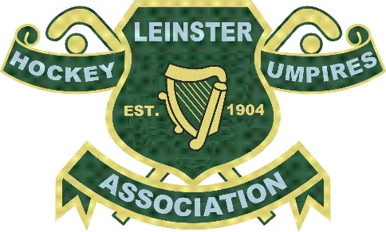

- Leinster Hockey Umpires Association
- Committee Meeting
- Attendee Names
  - Percy Henchy, Colm Kavanagh, Tom Goode, Bruce Bale, Darrell Reamsbottom (By Phone), Gillian Garrett, Tommy Doyle, Rob Abbott
- Attendees Not Present
  - Fiona Davitt

Approval of Previous Minutes
Read
Finance
TD to follow up with auditor for last 2 seasons accounts Action TD
Signatories yet to be changed only with online functionality Action TD & PH
Umpire payments for Leinster indoor comps to be revised as to LHA is paying and no LHUA Action RA
Digression made to Umpire from Kilkenny for expenses for this season only Action TD
Proposal for change in payment scheme for LHUA umpires made by BB further discussions and research to be done to have this changed for beginning 20-21 season Action BB &TD

Umpiring, Assessing & Coaching
List active umpires to be updated – Action TG
Ladies Appointments – none to date to be reviewed again end of season Action PH & TG

Upgrading of the following umpires Action TG
Simon Mac Allister B* -> A
Darrell Reamsbottom B -> B*
Rupert Christie C -> C*
Peter Motyer C -> C*
Sunny Charles Intro -> C
Richard Stone Intro -> C
Colm Kavanagh to be IHUA assess

Need a Whistler topic of discussion LHUA umpires taking on matches before / instead of LHUA appointments reminder email of best practices to be sent to members Action TG
Training, Development & Young Umpires
NUAC course to be arranged Action FD, RA, Kenny & TG
LHUA course to be arranged open to all like last one Feb 2020? Action BB & GG
9 new umpires came through the NUAC last year who need to be coached Action TG, RA & FD
Young Umpire activity LHA and David Curran to put plan in place supported by LHUA Action LHA
Google drive link to LHUA Committee Gmail for Umpire development opportunities from clubs Action RA & FD

Garda Vetting
87% completion support required to receive unvetted members Action CK & TG
CK raised a point which came up in the meeting with the LHA for Umpires outside Div 1, LHA must vet all members that are not appointed by LHUA because of the access to children piece. Action LHA
Social Media
Social media committee – CK, RA & BB

AOB
Constitution – Action CK to investigate with DA if one was updated and loction
Kit – Kit orders fulfilled, and deliveries arranged by BB any further orders to go through BB
RA email regarding appointments to girls’ schools matches agreed to try appoint to Semi Finals and Finals Action TG
LHUA radios – Radio manufacturer agreed (FBIM) working with IHUA to agree pricing and ordering Action BB
Xmas event comms to be sent out possible January Action BB

Next committee meeting mid to end of January

Meeting closed at 9.45pm
Minutes by Colm Kavanagh

