DATE: | Thursday, February 13th 2020
TIME: | 7.15pm
LOCATION: | Pembroke Wanderers HC
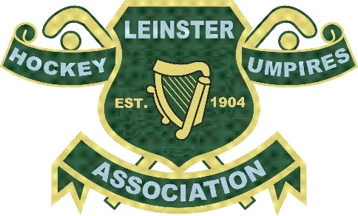

- Leinster Hockey Umpires Association
Committee Meeting
- Attendee Names
  - Percy Henchy, Colm Kavanagh, Bruce Bale, Darrell Reamsbottom Gillian Garrett, Tommy Doyle, Fiona Davitt
- Attendees Not Present
  - Rob Abbott (Euro Indoors), Tom Goode (sickness)

Approval of Previous Minutes
Read and approved
Finance
- 17/18 accounts received
Action: PH to speak to and follow up with auditor for 18/19 accounts to ensure they are complete and available for AGM
- Indoor payments for 20/21 season update from RA – Not present to give update

Umpiring, Assessing & Coaching
- Complaint – Committee in agreement that this will be passed onto the LHA disciplinary committee which was passed onto LHA along with colleagues’ comments
Action: TD to request feedback from colleague to forward to LHA - complete
- ‘Need a Whistler’
Action: TG to email branch umpires individually re advertising with rates
Action: TG to email to be sent to all umpires, including reminders:
Risk of umpiring a match before branch appointments - lateness / injuries
Best practices prior to game e.g. arriving no later than 30 mins before
LHUA jerseys are compulsory for LHUA appointed matches
Action: TG to email clubs that they should contact umpires on the Monday before matches to confirm match time colours etc.
Training, Development & Young Umpires
- Training Day Feedback 2019 – positive feedback received from Skerries HC in particular
- Development plan (RA and FD) update?
Action: RA and FD to meet with Dave Curran UDO of the LHA to plan
- Meeting with new umpires
Action: RA/FD to arrange

Garda Vetting
- Fully completed except for 1 umpire - complete
- Safeguarding course needs to be completed by all umpires (propose to do this in conjunction with IHUA and end of this or beginning of next season) – proposal agreed

Social Media
- Social media channels – committee agreed that we should increase the amount of content, including focusing on members who are away with EHF/FIH/Finals appointments for Irish umpires

AOB
- Radios – BB confirmed supplier agreed finalising details hope to have ready and distributed to umpires for start of season
- LHUA constitution
Action: CK to source and distribute to committee - complete
- Casual LHUA clothing
Action: BB to investigate
- On closing the meeting PH congratulated Bruce, Colm and Rob on their recent FIH and EHF appointments.

Meeting closed at 8pm
Minutes by Colm Kavanagh

